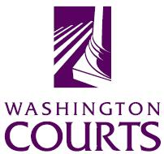 administrative office of the courts

June 29, 2018

TO: Judicial and Legal Communities

FROM: Merrie Gough, Senior Legal Analyst

SUBJECT: 2018 SUMMARY OF CHANGES TO EXTREME RISK PROTECTION ORDER FORMS

The Washington Pattern Forms Committee updated the Resources links in the Extreme Risk Protection Order Brochure. The links are now:

Frequently asked questions:
http://protectionorder.org/erpo/faq-extreme-risk-protection-orders.html

Information for respondent who has been served with an ERPO: http://protectionorder.org/erpo/ive-been-served-with-an-erpo.html

Information for respondent about turning in firearms:
http://protectionorder.org/erpo/how-do-i-turn-in-my-firearms.html

